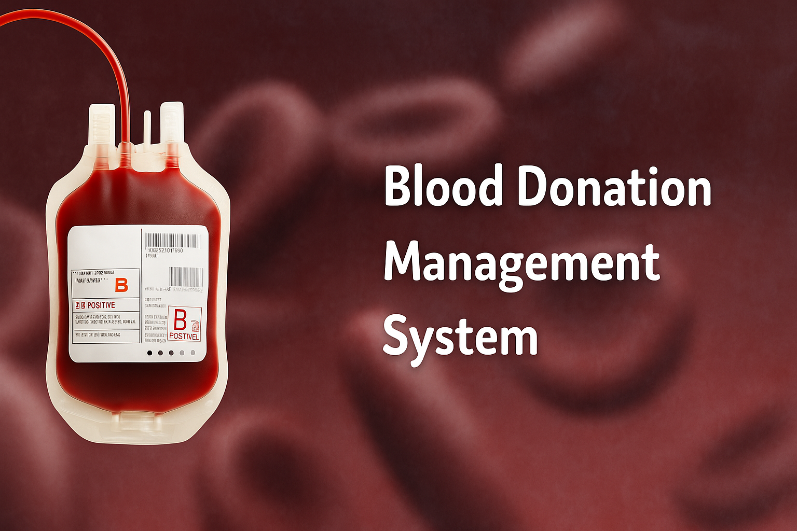

**INTRODUCTION**

**The Blood Donation Management System is a web-based application designed to connect blood donors with recipients and manage the blood stock efficiently. It streamlines the process of registering donors, accepting blood requests, and maintaining a database of available blood types. This system helps reduce the time and effort required to manually search for blood donors and allows for quick response during emergencies.**

**OBJECTIVE**

* **To create a centralized system to manage donor and recipient records.**
* **To automate the process of blood donation, request, and stock updates.**
* **To provide a search feature for available blood types.**
* **To ensure easy access and communication between donors and recipients.**
* **HTML, CSS (Frontend)**
* **PHP (Backend scripting)**
* **MySQL (Database)**
* **Bootstrap (for UI styling)**

**About the Language (PHP & MySQL)**

**🔸 PHP  
PHP (Hypertext Preprocessor) is a server-side scripting language used to develop dynamic and interactive websites. It integrates well with MySQL, making it perfect for database-driven applications like this system.**

**🔸 MySQL  
MySQL is a popular open-source relational database management system. It is used to store, retrieve, and manage data efficiently, such as donor information, requests, and stock records.**

**CODES:**

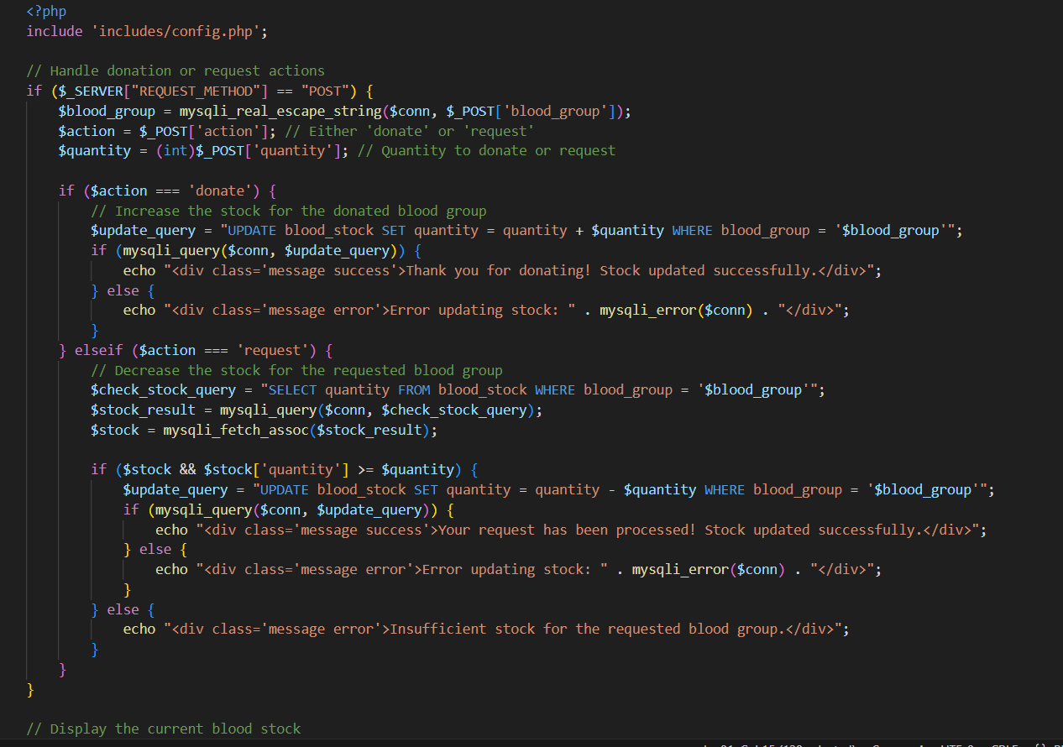

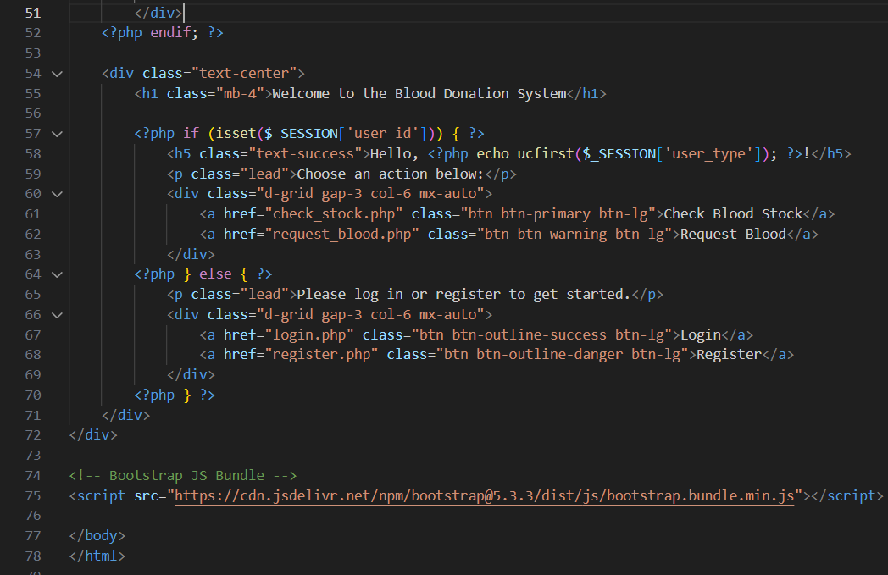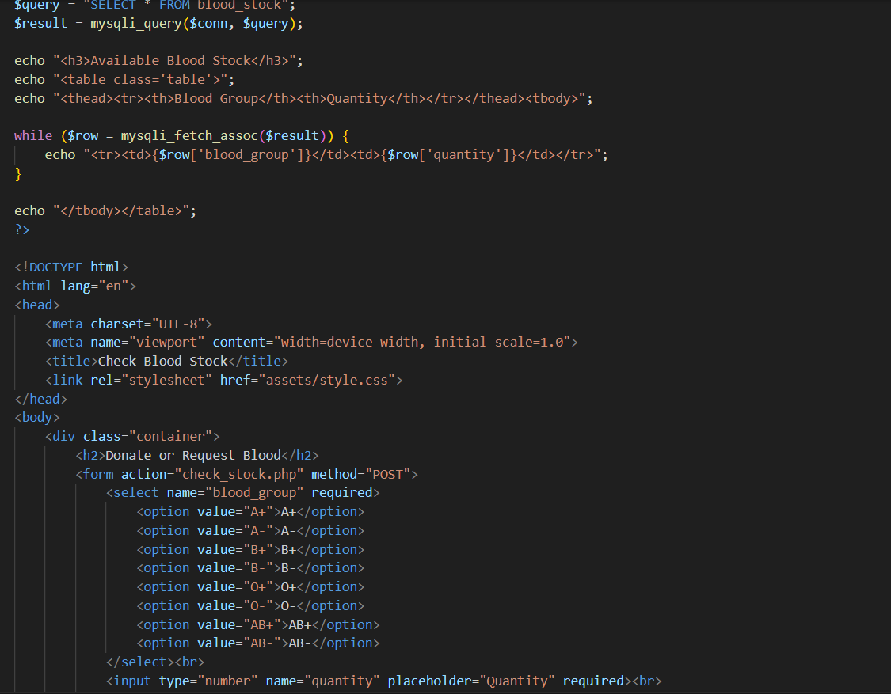

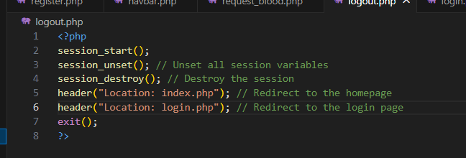

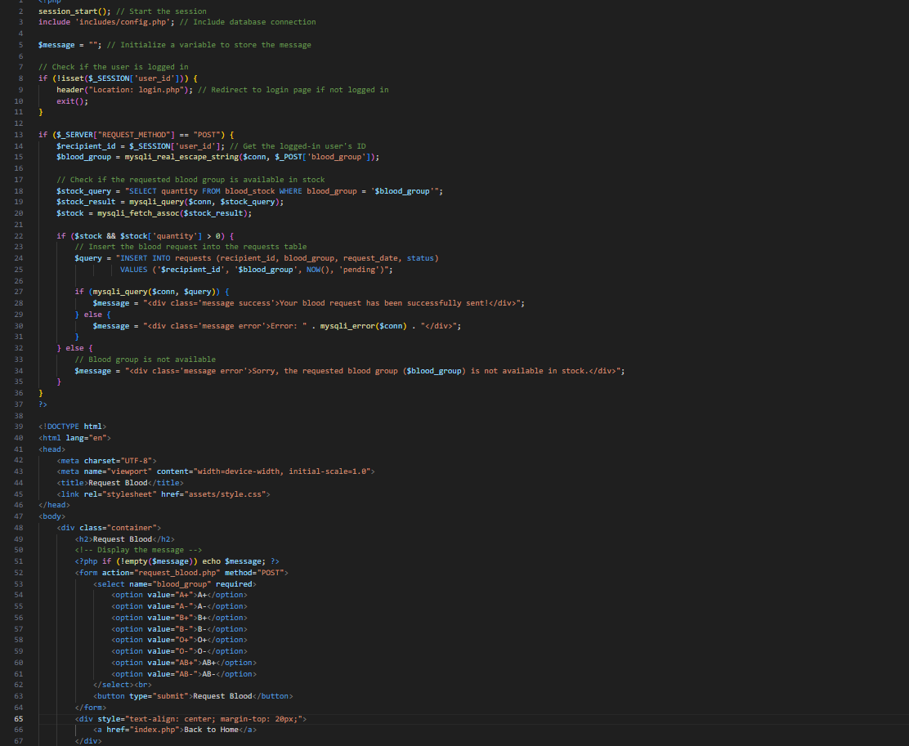

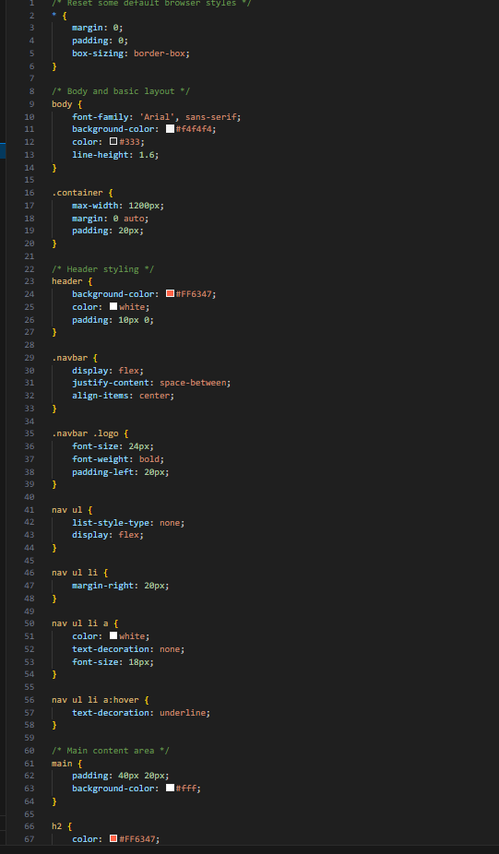**OUTPUTS:**

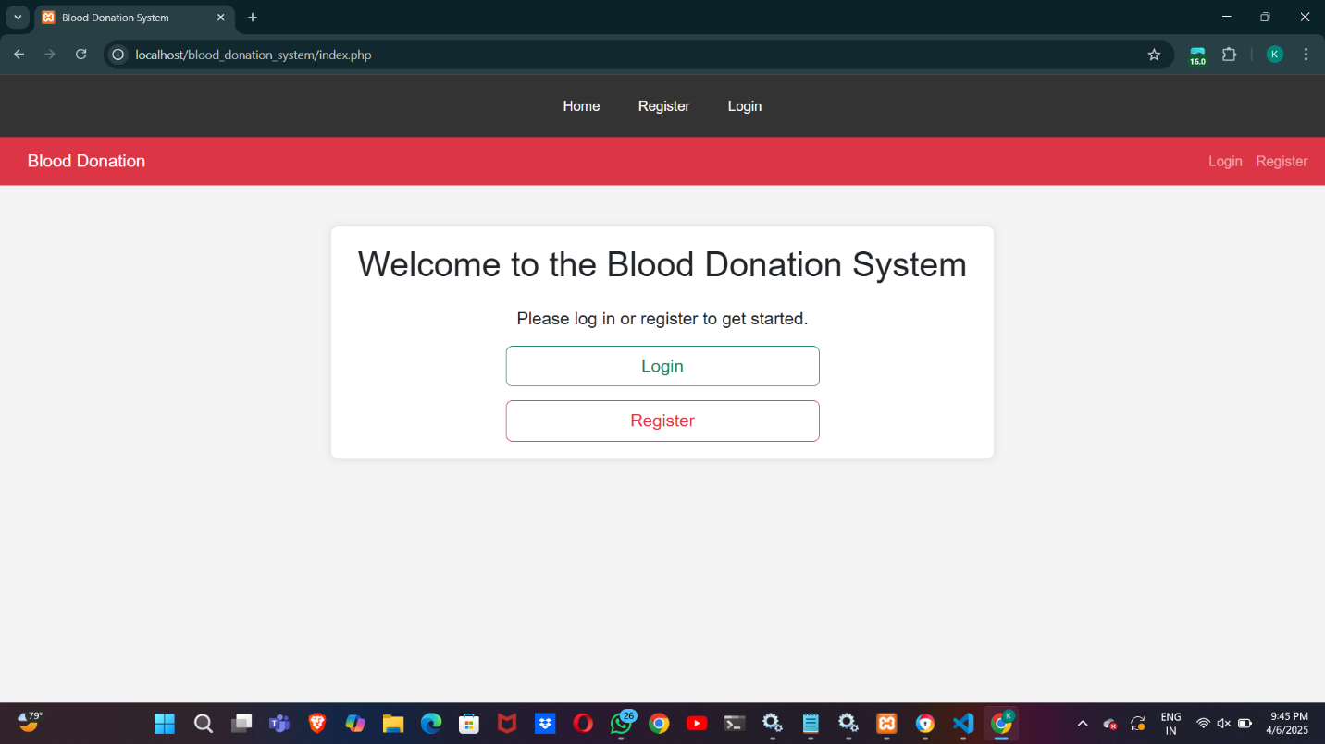

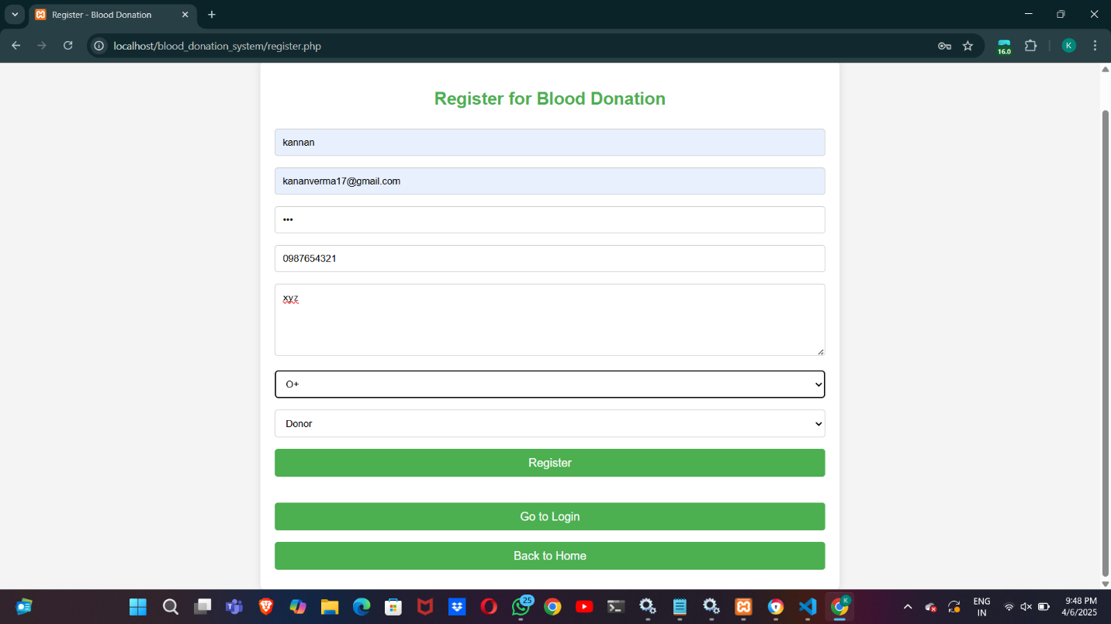

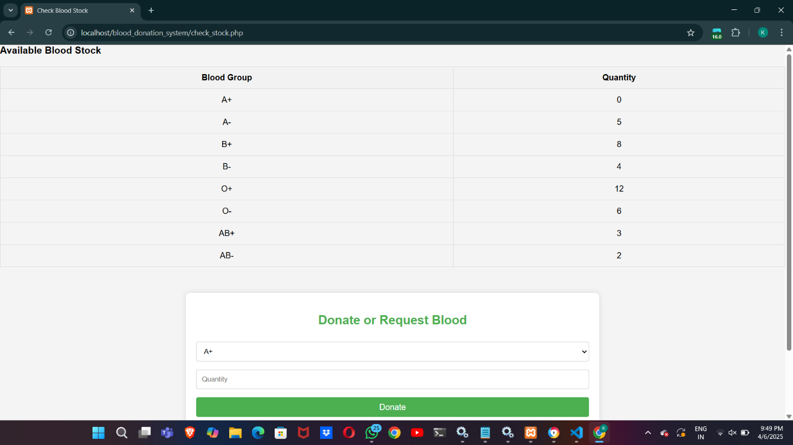

**CONCLUSION:**

**The Blood Donation Management System provides an effective way to connect donors and recipients, manage donations, and keep track of blood availability. It reduces manual workload, improves accessibility, and ensures faster response in emergency cases. Using PHP and MySQL made the development process efficient, scalable, and easy to deploy for small organizations, hospitals, and NGOs.**